**DS 501 STATISTICAL & MATHEMATICAL METHODS FOR DATA SCIENCE**

**ASSIGNMENT 5**

Name: Ali Nauman Roll Number: 18L1863

**PART 1: Data visualization via MDS**

Paste the scatter plot. Make sure you label the axis and make a legend to denote which color corresponds to which color.

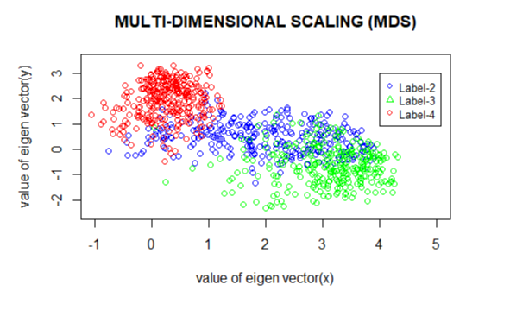

**PART 2: For digit 2:** Display only small sized 4 eigen digits corresponding to the highest Eigen value. They have to fit in the following space. You do not need to print in color. Grayscale is fine.

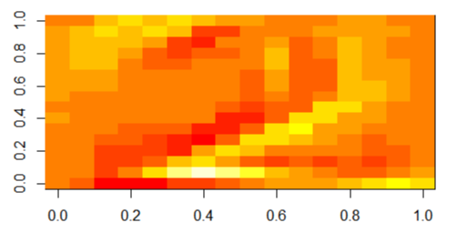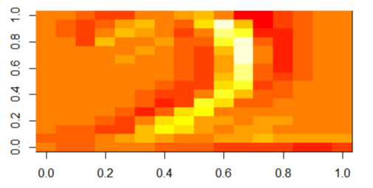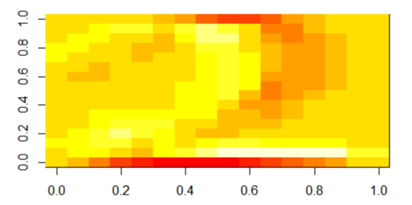

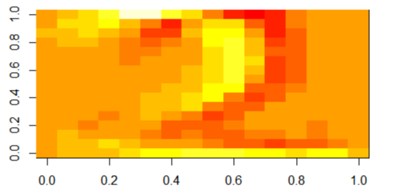

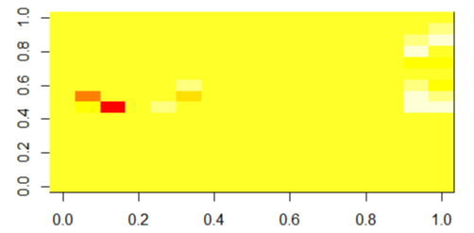Display 4 eigen digits corresponding to the lowest eigen value. They have to fit in the following space. You do not need to print in color. Grayscale is fine.

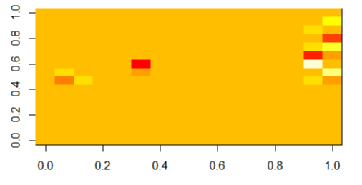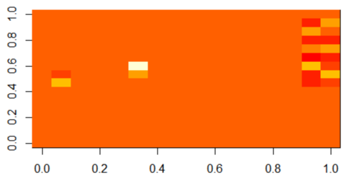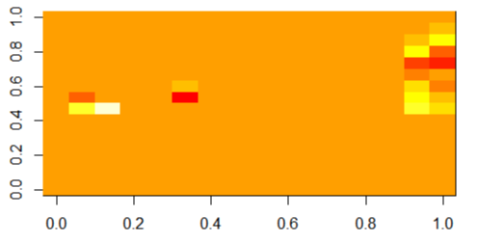

**PART 3: For digit 3:** Display only small sized 4 eigen digits corresponding to the highest eigen value. They have to fit in the following space. Grayscale is fine.

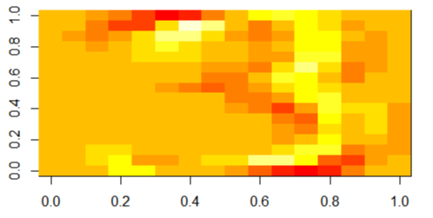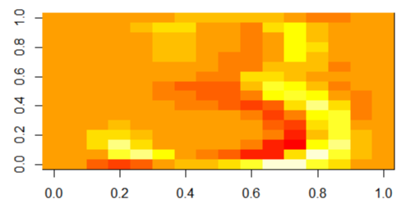

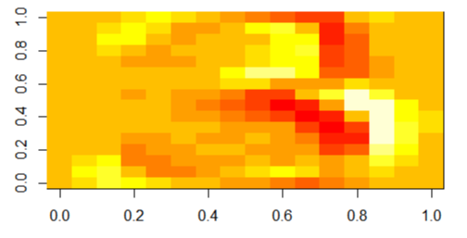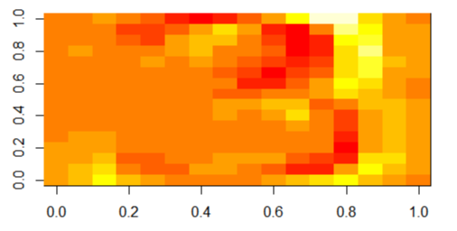

Display 4 eigen digits corresponding to the lowest eigen value.

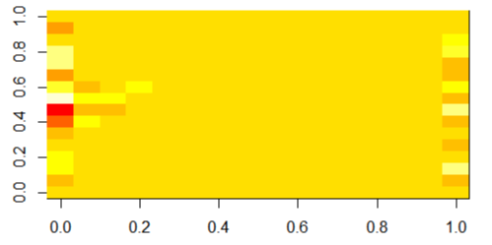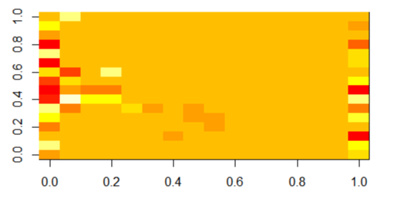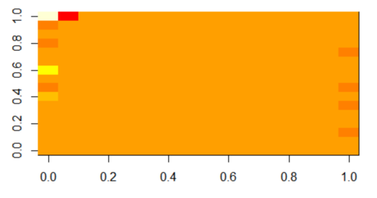

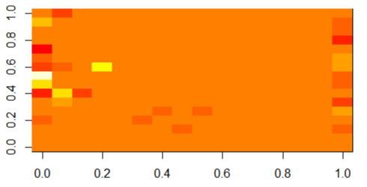

**PART 4: bonus (if done)**

**PART 5: Your observations:** Comment on MDS in 2-4 lines. Give 2-4 lines on YOUR opinion on how you can classify different digits using Eigen digits.

**MDS** has allowed us to map these features of the digits into a low, two-dimensional space. Thus, it projects from some unknown dimensional space to two dimensions. It has allowed us to create a cluster of how the digits are mapped in a two dimensional space. It is a typw of dimensionality reduction. We can easily see the distinguish between the coordinates of all digits as well.

It can be observed from figures that eigen digits corresponding to the highest eigen values makes the image of a digit more clearer as compared to eigen digits corresponding to lowest eigen value. However, a single eigen value and its corresponding vector does not resolve to the required digit. It gives out a very vague classification, where the dark color highlights the digit outline.